UML Diagram



|  |
| --- |
| Abstract Action |
| + Abstract Boolean occursOn: int year, int month, int days  + toString: description |
|  |



|  |
| --- |
| RegularAction extended Action |
| + RegularAction ()  + super ()  +Boolean occursOn: int year, int month, int days  + toString: description |
|  |

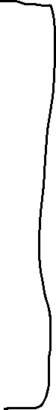

|  |
| --- |
| ActionDriver |
| main |
| + occursOn ()//call occurs method |



|  |
| --- |
| OccasionalAction extended Action |
| + OccasionalAction ()  + super ()  +Override // Boolean occursOn: int year, int month, int days return true and false  + toString: description |
|  |



|  |
| --- |
| RareAction extended Action |
| + RareAction ()  + super ()  +Override // Boolean occursOn: int year, int month, int days return true and false  + toString: description |
|  |



|  |
| --- |
| ActionDriver2 //testing the occasional Action and rare action |
| main |
| + occursOn ()//call occurs method equal |



|  |
| --- |
| AllActionTest |
| + int year, month, days |
| //loop starting from index 0 that will go all Actions and print them  for (int index = 0; index < act.length; index++) {  if (act[index].occursOn(year, month, days)) {  // print the action index in to string  System.out.println(act[index].toString());  } |

